CHAPTER 5
Externalities, Environmental Policy, and Public Goods
- Chapter Summary
- Learning Objectives
- Chapter Outline
Teaching Tips/Topics for Discussion
- Solved Problems
- Solutions to Review Questions and Problems and Applications

1. Chapter Summary
An externality is a benefit or cost that affects someone not directly involved in the production or consumption of a good or service. Negative externalities are costs imposed on non-consenting individuals. Positive externalities are benefits for individuals not directly involved in producing or paying for a good or service. Externalities interfere with the economic efficiency of a market equilibrium since they cause a difference between the private cost of production (the cost borne by the producer of a good or service) and the social cost, or the private benefit from consumption (the benefit received by the consumer of a good or service) and the social benefit. The social cost is the private cost plus any external cost resulting from production; the social benefit is the private benefit plus any external benefit that results from the consumption of a good or service.
When there is a negative externality as the result of production, the market supply curve understates the true (social) cost of production. A supply curve that reflects social costs would lie to the left of the market supply curve. The equilibrium market price occurs where the marginal social cost of production exceeds the marginal benefit to consumers and there is a reduction in economic surplus. Economic efficiency would be increased if less of the good or service were produced.
When there is a positive externality, the market demand curve understates the social benefits from consumption of a good, and the demand curve that reflects the social benefits of this good would lie to the right of the market demand curve. At the equilibrium point, the marginal benefit exceeds the marginal cost and a deadweight loss results. Because of the positive externality, too little of the good is produced.
Negative and positive externalities lead to market failure due to the absence of private property rights for physical property (for example, a store or factory) or intangible assets (for example, for a new idea to improve a production process). Market failure may also result from the difficulty of enforcing private property rights (for example, lax government enforcement of copyright laws). Most of the time, the governments of the United States and other high income nations provide adequate enforcement of property rights, but in certain situations, these rights do not exist or cannot be legally enforced. In certain circumstances, private solutions to the problem of externalities can be found, an idea suggested by Ronald Coase. The Coase Theorem is often applied to negative externalities, such as air pollution. Coase argued that there is an optimal level of pollution where the marginal benefit of reducing pollution is equal to the marginal cost. Those harmed by the pollution and who, therefore, would receive the benefits of reducing the level of pollution have an incentive to reach private agreements with polluters to reduce pollution levels. However, transactions costs – the time and other resources incurred in reaching a private agreement – often make private solutions to this type of externality not feasible.
When private solutions to externalities are not feasible, government intervention is justified. For example, by imposing a tax equal to the external costs that result from production of a good, government can “internalize” the externality. This causes the social, not just the private, cost of production to be borne by producers. In effect, the supply curve for the good shifts to the left. This supply curve would then cross the demand curve at a higher equilibrium price and lower equilibrium quantity. When production of a good produces a positive externality, government can internalize the externality by providing a subsidy to consumers. If the subsidy is equal to the value of the externality, this has the effect of shifting the demand curve for the good to the right; market equilibrium is achieved at the economically efficient level with a higher price and quantity.
To reduce pollution, governments have often used a “command and control” approach. This may involve government imposition of quantitative limits on amounts of pollution firms can emit or the installation of specific pollution control devices. An exception to the command and control approach was the U.S. government’s attempt to reduce acid rain pollution. In the Clean Air Act passed by Congress in 1990, a reduction in sulfur dioxide emissions, a major cause of acid rain, from electric utilities was mandated. To achieve this goal, utilities were allowed to buy and sell emissions allowances. Each allowance is equal to one ton of sulfur dioxide. So long as the total amount of emissions does not exceed an annual mandated maximum amount (by 2010 this amount will be 8.5 million tons), firms can emit sulfur dioxide in amounts equal to their allowances. Firms that face high costs of reducing sulfur dioxide have an incentive to buy more allowances than they have been allocated. Utilities that can reduce their emissions at low cost have an incentive to do so and sell some of their allowances. This program has achieved emissions reductions at much lower costs than had been expected in 1990. The success of the sulfur dioxide program has led some to suggest that a similar program be used by the United States and other nations to reduce emissions of so-called “greenhouse gases” that contribute to global warming.
Other reasons for government intervention are explained by whether goods are rival and excludable. Rivalry occurs when consumption of a good precludes its consumption by someone else. Excludability means that anyone who does not pay for a good cannot consume it. There are four categories of goods: (1) Private goods are both rival and excludable; (2) Natural monopolies are excludable but not rival; (3) Common resources are rival but not excludable; (4) Public goods are both nonrival and nonexcludable. Private markets can produce the efficient amounts of private goods but government intervention may be necessary to produce the efficient amounts of the other categories of goods.
The demand for a public good is determined by adding the price each consumer is willing to pay for a certain quantity of the good; individual demand curves are added vertically. The optimal quantity of a public good will occur where the demand curve derived in this manner intersects the supply curve. Because it is difficult to determine individual preferences, governments often provide public goods by using cost-benefit analysis or a political process to determine the quantity supplied.
Because common resources are not privately owned, there is a tendency for these resources to be overused. This tendency is often called “the tragedy of the commons.” External costs arise from the use of a common resource. Since the private cost is less than the social cost, the market equilibrium for the good occurs where the marginal cost exceeds the marginal benefit. Government intervention in this market may involve restricting access to the common resource.

2. Learning Objectives
Students should be able to:
- Identify examples of positive and negative externalities and use graphs to show how externalities affect economic efficiency.
- Discuss the Coase Theorem and explain how private bargaining can lead to economic efficiency in a market with an externality.
- Analyze government policies to achieve economic efficiency in a market with an externality.
- Explain how goods can be categorized on the basis of whether they are rival or excludable.
- Define a public good and a common resource, and use graphs to illustrate the efficient quantities of public goods and common resources.

3. Chapter Outline
Economic Incentives Spur Duke Energy Corporation to Reduce Pollution
1. The Duke Energy Corporation is a participant in the federal government’s program to reduce acid
rain emissions through a market-based approach. Duke and other utility companies are allowed to trade emissions allowances; the allowances permit the holder to emit a certain amount of sulfur dioxide.
►Teaching tips: Making the Connection 5-3 and An Inside Look discuss applying the lessons from the sulfur dioxide reduction program to the more complex problem of reducing carbon dioxide emissions to reduce global warming. One skeptic is author Michael Critchon, whose views are referred to at the end of An Inside Look. All of these readings provide an excellent backdrop for discussion of topics that command student interest.
Externalities and Efficiency
1. An externality is a benefit or cost that affects someone who is not directly involved in the production or consumption of a good or service.
- Positive externalities refer to benefits received from a good or service by consumers who do not pay for them.
- Negative externalities refer to costs incurred by individuals from a good or service for which no one pays.
- A private cost is a cost borne by the producer of a good or service.
- A social cost is the total cost of production, including both the private cost and any external cost.
- A private benefit is the benefit received by the consumer of a good or service.
- A social benefit is the total benefit from consuming a good, including both the private benefit and any external benefit.
- A negative externality causes the social cost of production for a good or service to be greater than the private cost. As a result, more than the economically efficient level of output is produced.
- A positive externality causes the social benefit from the production of a good or service to be greater than the private benefit. As a result, less than the economically efficient level of output is produced.
►Teaching tips: Industrial pollution is often cited as an example of a negative externality but smoking may also be used as a classroom example. Most college students grew up in an era where smoking was much less socially acceptable than when their parents and grandparents were young. Students are often stunned to learn that smoking – by both students and instructors – was allowed in many college classrooms as late as the 1970s. Although few, if any, colleges allow smoking in classroom buildings now, many bars and restaurants have smoking sections. One may ask students (a) if they would be willing to pay smokers to not smoke while they are in the same restaurant, or (b) if they have ever chosen to sit in a restaurant’s smoking section in order to avoid a longer wait for a table in a non-smoking section.

The research Jonas Salk and Albert Sabin and their colleagues used to develop vaccines for polio provides a good example of positive externalities. From the 1950s onward, parents whose children received polio vaccines would have willingly paid for research that provided this protection. If parents had paid even a small amount ($5 per child), this would have amounted to billions of dollars for the scientists’ efforts. Of course, no market mechanism existed to transfer revenue from these parents to the researchers, and markets produced less medical research than people desired.
2. Externalities result from the absence of property rights for resources (for example, air) or inadequate legal enforcement of property rights. Property rights are the rights individuals or businesses have to the exclusive use of their property, including the right to buy or sell it.
- Market failure refers to situations where the market fails to produce the efficient level of output.
- Figure 5-1 illustrates the effect of acid rain on the market for electricity and the deadweight loss that occurs due to a negative externality.
- Figure 5-2 illustrates the impact of a positive externality in the market for a college education and the deadweight loss caused by this externality.
►Teaching tips: According to the U.S. Department of Agriculture, the average American consumes 223 pounds of beef, pork, and chicken annually. Despite the large and continuing demand for meat, one does not see news reports of shortages of cows, pigs and chickens. In contrast, there are occasional media reports of over-fishing and the possible of extinction of some animal species. When resources are privately owned, owners have incentives to conserve on their use; producers have strong incentives to maintain the stocks of cows, pigs and chickens to ensure a future supply of these. Property rights to some parts of oceans, rivers, lakes and habitat areas of endangered species are non-existent or are poorly enforced.
Private Solutions to Externalities: The Coase Theorem
1. Ronald Coase argued that private bargaining may improve upon inefficient market results caused by externalities.
- The Coase Theorem is the argument that if transactions costs are low, private bargaining will result in an efficient solution to the problem of externalities.
- Transactions costs are the costs in time and other resources that parties incur in the process of agreeing to and carrying out an exchange of goods and services.
- Successful application of the Coase Theorem requires that bargaining parties have full information regarding the costs and benefits associated with the externalities and they must be willing to accept a reasonable agreement. In practice, private solutions are not often feasible.
2. In the absence of private solutions to externalities, government intervention is warranted. To achieve economic efficiency, governments may intervene in different ways.
- To reduce pollution, “command and control” policies have often been employed. A command and control approach refers to government-imposed quantitative limits on the amount of pollution firms are allowed to generate, or government-required installation by firms of specific pollution control devices.
- Since 1990, a market-based approach to reducing sulfur dioxide emissions from electric utilities has reduced emissions at much lower cost than was expected. The success of this approach has led economists to advocate more extensive use of market-based approaches, and less use of command and control policies, to reduce other forms of pollution.
►Teaching tips: Economists working for the private research group, Resources for the Future (RFF), are among the strongest supporters of a system of tradeable emissions allowances to reduce the problem of acid rain. One of the difficulties of formulating environmental policy is that it is often difficult to put a dollar value on environmental damage; for example, the breathing difficulty people with asthma experience due to sulfur dioxide pollution. Economists at RFF have pioneered techniques for measuring the value of things for which no market price exists. Although one may not want to spend classroom time discussing research done at RFF, students interested in environmental economic issues can be referred to the RFF web site: www.rff.org. RFF, located in Washington D.C, has a summer internship program that provides opportunities for undergraduates to do research with environmental economists.
Four Categories of Goods
1. Goods may be classified into four categories based on whether or not their consumption is rival and excludable. Rivalry is the situation that occurs when one person’s consuming a unit of a good means no one else can consume it. Excludability is the situation in which anyone who does not pay for a good cannot consume it.
- A private good is a good that is both rival and excludable.
- A common resource is a good that is rival but not excludable.
- In a natural monopoly, the good is excludable but not rival.
- A public good is a good that is both nonrivalrous and and nonexcludable.
- Free riding refers to benefiting from a good without paying for it.
Public Goods and Common Resources
1. In contrast with private goods, consumers will consume the same quantity of a public good.
2. The demand for a public good is determined by adding the price each consumer is willing to pay for each quantity of the good. Since no consumer can be excluded from receiving the good, it is difficult to determine consumers’ true preferences and willingness to pay.
- Figures 5-9 and 5-10 describe how the demand for a public good is derived.
- Governments typically provide public goods, such as national defense, and determine the quantity supplied through cost-benefit analysis or a political process.
►Teaching tips: One may ask students to review Figure 5-8 and ask for other examples of the four types of goods. Assigning Solved Problem 5-2 as a homework problem will help students understand the atypical nature of the demand for public, as opposed to private, goods.

4. Solved Problems
Chapter 5 of the textbook includes Solved Problems that support Learning Objective 3 (Analyze government policies to achieve economic efficiency in a market with an externality) and Learning Objective 5 (Define a public good and a common resource, and use graphs to illustrate the efficient quantities of public goods and common resources). The following Solved Problems support other learning objectives from this chapter.

Solved Problem 5-3 (a)
Supports Learning Objective 1: Identify examples of positive and negative externalities and use graphs to show how externalities affect economic efficiency.

Smoking at Ike’s Bar-B-Q Pit
By the spring of 2005, 16 states, including California, Florida, Massachusetts and New York, had enacted laws to prohibit smoking in restaurants, bars and/or workplaces. But Ike’s Bar-B-Q Pit is not located in any of these states. Some of Ike’s non-smoking customers, including some who suffer from asthma, have petitioned Ike to adopt a no-smoking rule for his restaurant. Upon hearing of the petition, some of Ike’s other customers complained that they have smoked in Ike’s restaurant for years and would not patronize the restaurant if the no-smoking rule were adopted. Ike is greatly concerned as he does not wish to lose business from either his smoking or non-smoking customers.

Draw a graph illustrating the externality associated with Ike’ Bar-B-Q Pit and explain how this externality causes a deviation from economic efficiency in this market.

Solving the Problem:
Step 1: Review the chapter material. This problem concerns the material from the Externalities and Efficiency section of the textbook that begins on page 132. You may want to review the section before completing this problem.
Step 2: Draw a graph to illustrate the externality at Ike’s Bar-B-Q Pit. This is a negative externality since there are external costs imposed on Ike’s non-smoking customers as a result of breathing in second-hand smoke. These are costs that neither Ike nor his smoking customers have to pay.

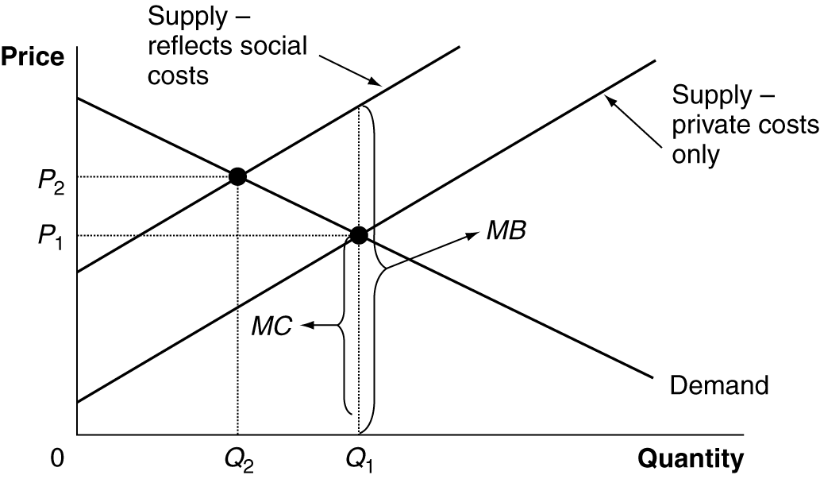

Step 3: Describe how the externality causes a deviation from economic efficiency. The economically efficient outcome is for the quantity of meals served at Ike’s restaurant to be Q₂ and the price of the meals to be P₂. (Ike’s no doubt has a varied menu with different meals with different prices. To simplify this problem, one may assume P₂ is an average meal price.) This is where the equilibrium point would be if the market supply curve that reflected social costs, including the negative health effects on non-smokers, crossed the demand curve. At this point, the marginal benefit from Ike’s meals would equal the marginal social cost. However, since neither Ike nor his smoking patrons have to pay for the negative externality, the market supply curve reflects only private costs; as a result, the equilibrium market price and quantity are P₁ and Q₁. At this point, the marginal social cost from Ike’s meals exceed the marginal benefit.

Source: Americans for Nonsmokers’ Rights, http://www.no-smoke.org

Solved Problem 5-3 (b)
Supports Learning Objective 1: Identify examples of positive and negative externalities and use graphs to show how externalities affect economic efficiency.

Finding a Cure for Malaria
Malaria is a serious disease caused by a parasite. Patients with malaria typically suffer from high fevers, chills, and flu-like symptoms. The World Health Organization estimates that 300 to 500 million cases of malaria occur each year. For more than 1 million people, the disease is fatal. Only about 1,300 of these cases are diagnosed in the United States; most of these cases involve people who contracted the disease after traveling abroad to malaria-risk areas. The disease is usually transmitted through a bite from an infected Anopheles mosquito.

Draw a graph illustrating the impact associated with research directed at finding a cure for malaria. Assume that all research efforts are funded through private markets.
Solving the Problem:
Step 1: Review the chapter material. This problem concerns the material from the Externalities and Efficiency section of the textbook that begins on page 132. You may want to review the section before completing this problem.
Step 2: Draw a graph to illustrate the externality associate with privately funded research to cure malaria.

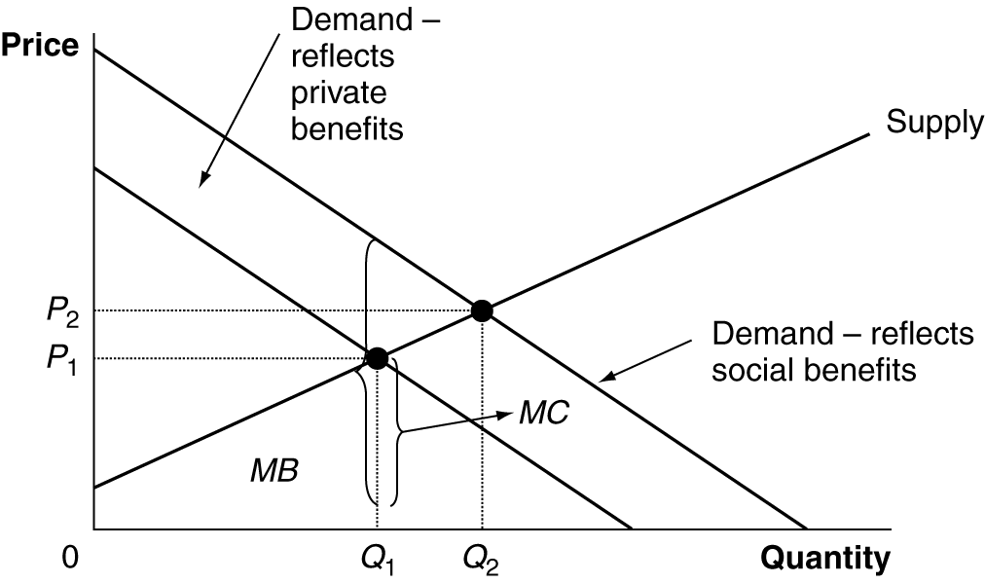

Step 3: Describe how the externality causes a deviation from economic efficiency. There is a positive externality associated with malaria research because of the external benefits it generates. Assume that researchers were to find a cure for malaria. Using the World Health Organization’s figures, 300 to 500 million people (this is just for one year) could be cured of malaria. Even if the benefits to these people were very conservatively estimated at $2 each, the external benefits would be $600 million to $1 billion. Of course, the research is by nature uncertain and scientists and doctors can work many years without finding a cure. Private hospitals and research laboratories are likely to receive a relatively small amount of the social benefit from their efforts. As a result, the private demand for malaria research will be less than the demand that reflects social benefits. The private market equilibrium price and quantity would be P₁ and Q₁; at this point the marginal social benefit (MSB) would exceed the marginal cost (MC). The economically efficient level price and quantity would be P₂ and Q₂, where marginal social benefit is equal to marginal cost.

Source: Centers for Disease Control and Prevention. http://www.cdc.gov/malaria/faq.htm

Solved Problem 5-4
Supports Learning Objective 2: Discuss the Coase Theorem and explain how private bargaining can lead to economic efficiency in a market with an externality.

Ike’s Bar-B-Q Pit Reaches A Coase Solution

Refer to Solved Problem 5-3(a). Since Ike’s restaurant is not in a state that regulates smoking in public places, Ike decides to meet with his smoking and non-smoking customers to accommodate both of their wishes regarding his smoking policy. Suggest a solution that would be consistent with the Coase Theorem.

Solving the Problem:
Step 1: Review the chapter material. This problem concerns the material from the textbook section Private Solutions to Externalities: The Coase Theorem that begins on page 135. You may want to review the section before completing this problem.
Step 2: Describe the type of solution that would bring about an efficient outcome and be consistent with the Coase Theorem. Private bargaining between those who are the source of the externality and those who are affected by the externality could result in a solution that is satisfactory to both parties.
Step 3: Suggest a solution that would enhance the well-being of Ike’s customers and increase economic efficiency. One possible solution is to construct a wall separating Ike’s restaurant into smoking and non-smoking sections. This would raise the cost of providing meals at Ike’s and, in effect, shift the supply curve that reflects private costs from the graph in Solved Problem 5-3 (a) to the left. The costs of doing this could be passed on to either or both groups of customers. It would not matter if the costs were paid for by the smokers or non-smokers, so long as the economically efficient rate of output were achieved where the marginal social cost equals the marginal benefit from the meals served at Ike’s.

Solved Problem 5-5 What is a public good? What is a common resource?
Supports Learning Objective 5: Define a public good and a common resource, and use graphs to illustrate the efficient quantities of public goods and common resources.

(a) State the definition of a public good and use a graph to illustrate the efficient quantity of this good.
(b) State the definition of a common resource and use a graph to illustrate the efficient quantity of this resource.

Solving the Problem:
Step 1: Review the chapter material. This problem concerns the material from the textbook section Public Goods and Common Resources that begins on page 148. You may want to review this section before completing this problem.
Step 2: Define a public good. A public good is a good that is: (a) nonrivalrous – this means that one person’s consumption of the good does not interfere with another person’s consumption, and (b) nonexcludable – this means that it is impossible to exclude anyone from consuming the good, whether they have paid for it or not.
Step 3: Construct a graph to illustrate the efficient quantity of a public good. An example of a public good is the weekly radio broadcast of “A Prairie Home Companion” by Garrison Keillor. This program is distributed by American Public Media to public radio stations throughout the United States. A person with a radio within range of a broadcast of this program can listen to it without having to pay for it, and this person’s consumption does not interfere with any other listener. As shown in Figure 5-10 and Solved Problem 5-2 in the textbook, the demand curve for a public good is derived by adding the price each consumer is willing to pay to purchase each quantity of the good. The optimal amount of the public good is determined at the intersection of the demand curve derived in this manner with the supply curve. The supply curve for “A Prairie Home Companion” is shown as a vertical line at a quantity of 2 hours per week, the number of original broadcast hours. The efficient price P_{EFF} could help determine the amount of funding sought from the Corporation for Public Broadcasting and private donations to help pay for the broadcasts. Since listeners have an incentive to be free riders, public radio stations have difficulty determining the true demand for the program.

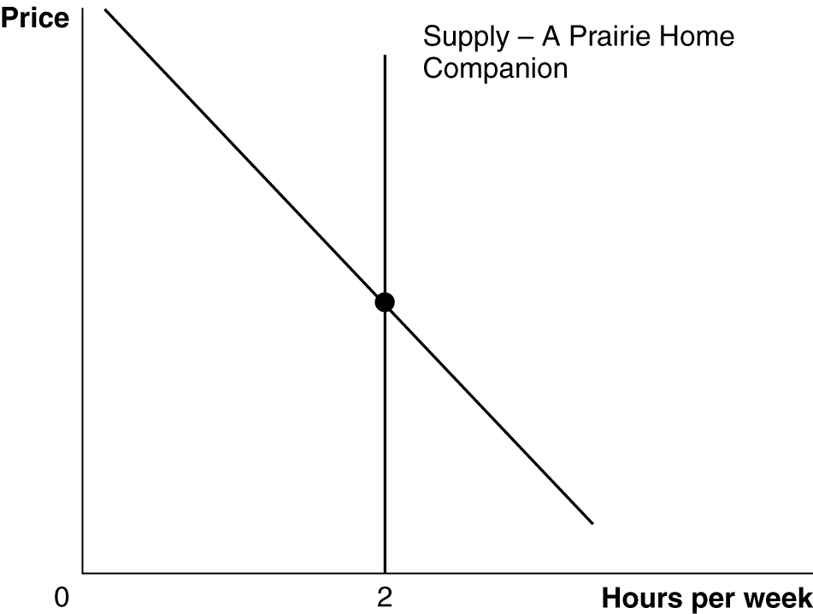

Step 4: Define a common resource. A common resource is a good that is rival but not excludable. This means that no one can be prevented from using the resource whether he paid for it or not, but one person’s use reduces the amount that is available for others.
Step 5: Construct a graph to illustrate the efficient quantity of a common resource. Figure 5-12 shows that the efficient quantity of a common resource, such as wood from a forest that is commonly owned, is less than the quantity produced in a private market. The efficient price is greater than that produced in a private market.
Source: http://prairiehome.publicradio.org/

5. Solutions to Review Questions and Problems and Applications

Answers to Thinking Critically Questions

1. No, if carbon dioxide emissions don’t harm the environment, the market outcome is already efficient. The tax would create a deadweight loss, as in Figure 4.9.

2. If the external benefits equal the external costs, the two offset each other and the market is efficient. A tax or a subsidy would move the economy away from efficiency. If the external benefits are larger than the external costs, the government could bring the economy to efficiency with a subsidy of the right size. If the external costs are larger than the external benefits, the government could bring the economy to efficiency with a tax of the correct size.

Answers to Review Questions

1. An externality is a benefit or cost that affects someone who is not directly involved in the production or consumption of a good or service. Examples of a positive externality include a) the benefits received by a passerby who enjoys a beautiful garden and b) the benefits from a college education that go to one’s children, grandchildren, co-workers, or complete strangers. Examples of negative externalities include a) the noise from a loud party or from a jetliner, and b) the pollution emitted from a factory.

2. The private cost of producing a good will differ from the social cost when there is a negative externality. For example, the private cost of producing electricity includes the costs of the fuel and running the power plant, but the social cost also adds the costs of the pollution emitted – which can reduce visibility and cause health problems. The private benefit of consuming a good differs from the social benefit when there is a positive externality. For example, the private benefits from your college education include your enjoyment of the experience and the increase in income you’ll receive, but the social benefits add the benefits to third parties, such as your potential co-workers’ improved productivity because you know more, or the gains to people who receive more from the government because you earn more and pay more taxes.

3. Economic efficiency occurs when the marginal benefit to consumers of the last unit produced is equal to its marginal cost of production, and where the sum of consumer surplus and producer surplus is maximized. Externalities generally reduce economic efficiency because the buyers and sellers ignore the external cost or benefit and so over- or under-produce the good.

4. Market failure is the failure of the market to produce the efficient level of output. Externalities, public goods, and common resources all cause market failure (as does monopoly, which you’ll learn about in a later chapter).

5. Externalities generally arise because of incomplete property rights or from the difficulty in enforcing property rights.

6. The economically efficient amount of pollution isn’t zero in most cases. Eliminating all pollution would incur costs that are greater than the benefits. The economically efficient amount of pollution is the amount at which the marginal cost of eliminating another unit just equals the marginal benefits from eliminating it.

7. The Coase Theorem argues that if transactions costs are low, private bargaining will result in an efficient solution to the problem of externalities – for example, in the efficient amount of pollution. Transactions costs are the costs in time and other resources that parties incur in the process of agreeing to and carrying out an exchange of goods or services. Private solutions to the problem of externalities are most likely when it is easy to define and enforce property rights and when the costs of making a deal are low.

8. A Pigovian tax is one which aims to bring about an efficient level of output by setting the tax equal to the marginal external cost (which is the difference between the marginal social cost and the marginal private cost).

9. Most economists favor tradable emissions allowances because they allow pollution to be reduced at the lowest cost. The firm that can reduce pollution cheaply will do so and sell its right to emit to another firm whose costs of reducing pollution are high. The command and control approach is generally much costlier, because it often forces firms to adopt expensive methods of pollution control.

10. Rivalry occurs when one person’s consuming a unit of a good means that no one else can consume it. Excludability occurs when anyone who doesn’t pay for a good cannot consume it. Rival-excludable goods are called private goods, which comprise most of the goods we consume. Rival-nonexcludable goods are called common resources – such as fish in the sea. Nonrival-nonexcludable goods are called public goods. Nonrival-excludable goods are often called natural monopolies.

11. A public good is nonrival and nonexcludable. Because anyone can get it without paying once it has been produced – attempting to “free ride” in this manner – there is often little incentive for firms to supply the good, since they can’t make a profit if people don’t pay for the good. Free riding will lead to market failure, as less than the efficient amount of the good will be produced.

12. The tragedy of the commons is the tendency of a common resource to be overused. It can be avoided if there is a way to block overuse. One method is to give someone a property right to the resource, giving them the incentive to use it efficiently. However, this won’t work well if they cannot enforce their property right easily.

Answers to End-of-Chapter Problems and Applications

1. Under these circumstances, consumption of Big Macs causes negative externalities, and these types of externalities exist in the consumption of many products. There has recently been a debate over whether the health effects of high-fat fast food justifies government intervention. Ironically, the person with health problems due to a lifetime of burger consumption didn’t cause the externality on taxpayers until the government created Medicare. In some sense, the government created the externality by taking the cost upon itself.

2. Drinking excessive amounts of alcohol is an example of consumption generating a negative externality. One example of production generating a positive externality is the production of honey, as described in Making the Connection 5-2.

3. Unlike hamburgers, college educations are believed to generate sizeable positive externalities, thus justifying subsidies, which will increase output toward the efficient amount.

4. There is a positive externality in production. Because of the way premium cable channels are marketed, a hit program on one channel will increase sales of other channels. It is possible to think of a private agreement in which other cable channels assume some of the production costs of hit shows, but negotiating such an agreement would be difficult.

5. An increase in pollution could make society better off if the current level of pollution is below the efficient amount. For example, government restrictions could be so strict that they reduce pollution to level A in the figure. The marginal costs of the last unit of pollution reduction exceed the marginal benefits, so society would be better off if pollution reduction was only level B – the efficient amount.

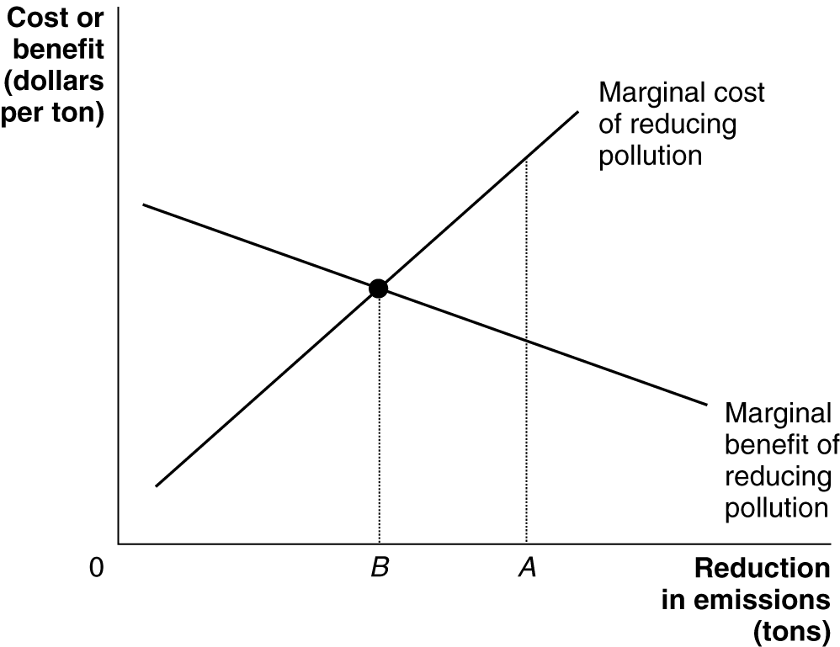

6. Yes, assuming that the marginal benefit does not drop to zero before all of that type of pollution is eliminated.

7. The marginal benefit to reducing crime would include the reduction in losses to crime victims, including losses due to personal injury and anxiety. The marginal cost of reducing crime would include resources devoted to police, courts, and prisons. Just as with pollution, it would not be economically efficient to reduce the amount of crime to zero.

8. By market failures, she means that an unregulated market will result in more than the economically efficient amount of wetlands and forests being developed. Habitat loss refers to the conversion of wetlands and forests into developed land. Because the market fails to take into account the external cost of lost forests and wetlands, an inefficiently large quantity of land (Q₁) is developed. The efficient level of land development is Q₂, which is determined by the intersection of demand and S₂.

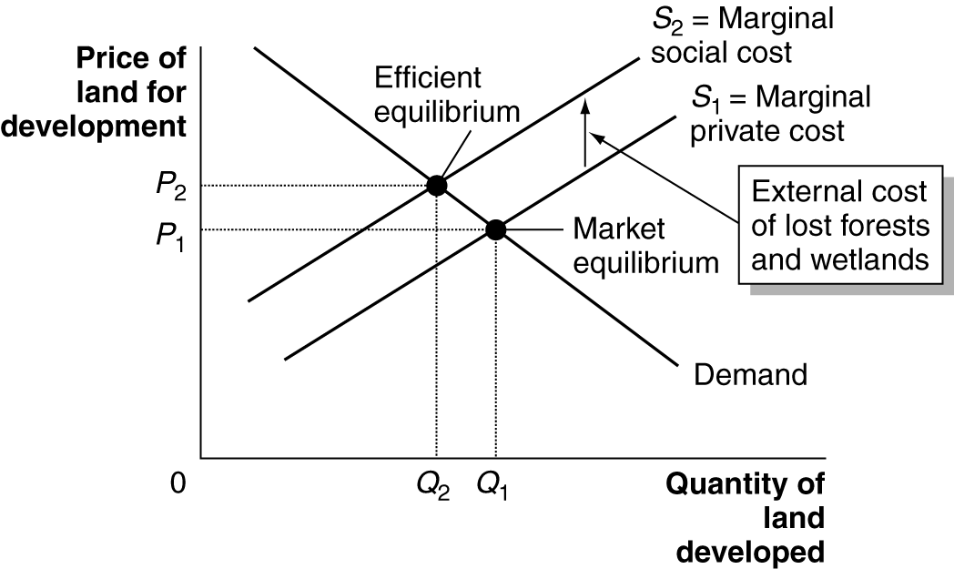

9. Yes, subsidizing something that generates external benefits can help increase the amount produced toward the efficient level. (Although output of new technology may become too high if the subsidy is too big.) The U.S. government does subsidize the production of new technology by providing grants to researchers through the National Science Foundation and other agencies.

10. You will disagree because the marginal benefit of reducing sulfur dioxide emissions all the way to zero will be very low, but the marginal cost will be very high.

11. As the level of pollution falls, further reductions become increasingly costly. Cleaning up the first one percent is easy – you merely scoop up oil that is floating in the water or lying on the shore. Cleaning up the last percent is hard because it has oozed into places that are hard to reach. To completely remove all of the oil from a spill can require very complex and expensive technologies. Removing the last one percent may even be more damaging to the ecosystem than leaving it there. Another tradeoff involves spending resources to completely clear an oil spill versus using those resources for other purposes.

12. The managers of firms in the Communist system were usually rewarded for fulfilling production quotas. They were usually not penalized for any pollution they might generate. In addition, because individuals had limited – if any – rights to private property, there were fewer checks on polluting the land, water, and air than under a market system.

13. A normal good is a product that consumers demand more of as income rises. Environmental protection is a normal good. The developed nations of the West already had higher incomes than third world countries do today when they first began to take significant steps to protect the environment. Because third world countries have low incomes, they do not demand nearly as much environmental protection as developed countries do. As an economy develops and people get richer and they can afford to pay more for a clean environment, their willingness to pay for a clean environment rises – so the marginal benefit curve for pollution reduction rises. Economic development also brings new technologies that reduce the marginal cost of reducing pollution.

14a. The tax should be the amount necessary to shift up the supply curve from S₁ to S₂. That amount is $7.50 – $7.15 = $0.35 per item dry-cleaned.

14b. The deadweight loss from excessive dry cleaning arises because the efficient amount of items to dry clean is 600,000 per week, but the market outcome is 750,000 per week. The deadweight loss equals the amount by which the marginal social cost (S₂) of cleaning the last 150,000 items exceeds the marginal benefit (which equals the demand curve). This is shown by area A of the figure: 0.5 x $0.35 x 150,000 = $26,250.

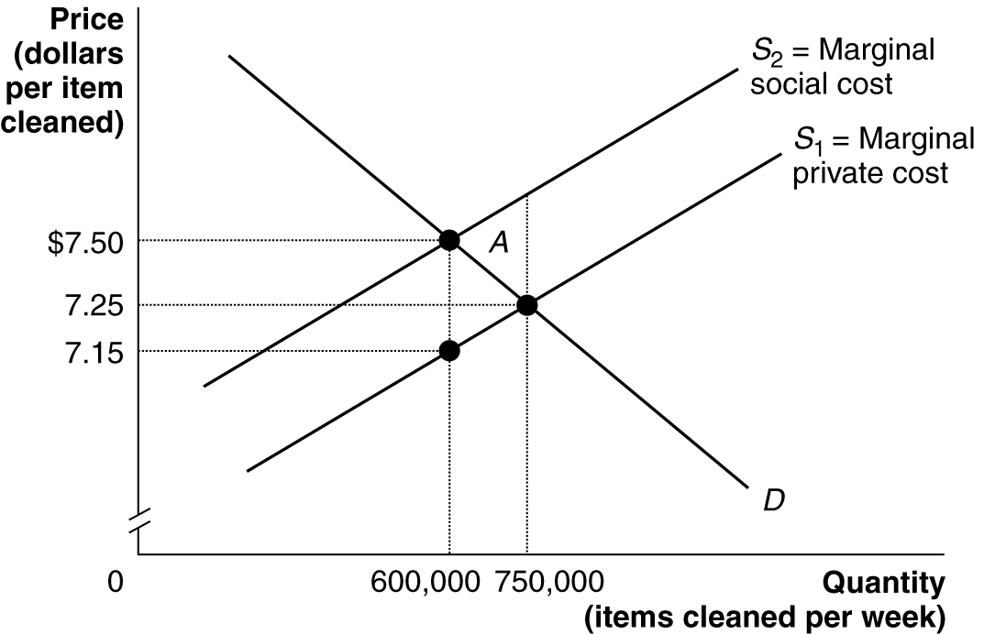

15a. Marginal external cost is the difference between the marginal social cost and the marginal private cost curve. Because marginal external cost rises as output rises, the gap between the marginal private cost curve and the marginal social cost curve gets larger as output rises.

15b. The optimal Pigovian tax can be found by first finding the efficient level of output, which is found at the intersection of the demand curve and the social cost curve. At this output, the optimal tax equals the gap between the social cost and the private cost curves – that is, it equals the amount of the marginal external cost. Therefore, in the large city the optimal tax is $6.60 - $5.40 = $1.20, but in the small city the optimal tax is only $5.60 – $5.00 = $0.60.

16a. The optimal level of a public good occurs at the quantity where the public’s marginal benefit from the good – as represented by the demand curve – is equal to the marginal cost of providing the good. To solve the problem, we need to know the demand curve for the city park and the marginal cost of providing the park. To calculate their overall demand, we need to add the dollar amounts that Jill and Joe are willing to pay at each quantity:

Demand
Price per acre | Number of acres
$25 | 0
23 | 1
21 | 2
19 | 3
17 | 4
15 | 5
13 | 6
11 | 7
9 | 8
7 | 9

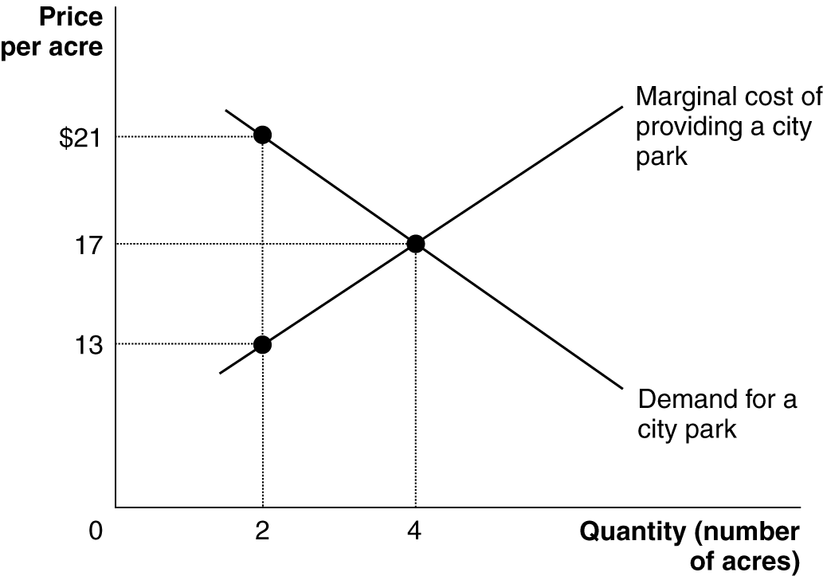

The graph shows that the optimal size park – where marginal cost equals marginal benefit – is 4 acres.

16b. The marginal cost of supplying the second acre is $13. But the demand curve tells us that the marginal benefit Jill and Joe receive from the second acre is $21. Because the marginal benefit to society is well above the additional cost, 2 acres cannot be the optimal size city park.

17. The tragedy of the commons refers to the tendency for a common resource to be overused. Because whales are a common resource, in the absence of agreements among governments to control whaling, several species have been hunted toward extinction.

18. People who produce and distribute new ideas have trouble capturing all of the benefits from the new ideas. As a result, they lack the incentive to produce the optimal quantity of new ideas.

19. The tragedy of the commons refers to the tendency for a common resource to be overused. It arises because each person using the commons neglects the effects his use has on other users. This is similar to each person neglecting to take into account the effects on others – in the form of speeding the development of drug-resistant microbes – from using antibiotics.

20. The total amount of sulfur dioxide pollution would decline because some allowances would no longer be available. Because the demand for allowances would increase, the price will rise.

21. Judging fairness is often difficult. While some countries may be able to buy their way out of having to reduce CO₂ emissions, the ones that end up buying emissions permits won’t necessarily be the richest ones, rather they will be the ones for whom the costs of reduction are the highest. Rich countries may sell the permits, if they have the technology that will allow them to cut back emissions cheaply. Trading emissions may be considered fairer by some because it allows emissions to be reduced more cheaply and pays the money to those who reduce their emissions the most.

22.

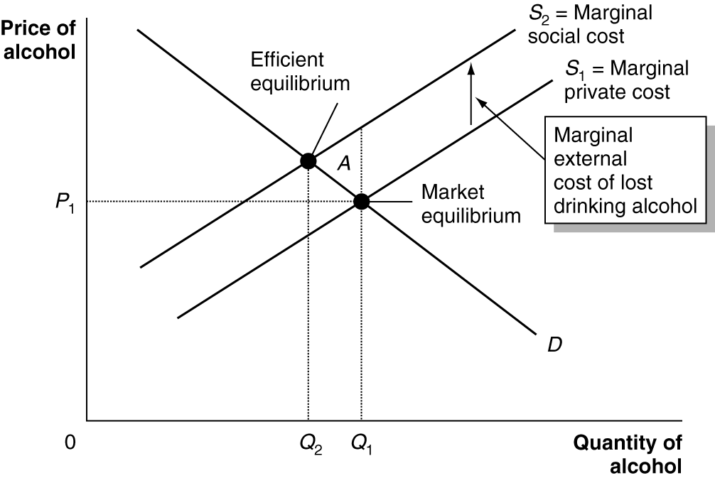

The efficient amount of alcohol consumption is Q₂, but because the negative externality is ignored actual consumption is Q₁. The deadweight loss is area A.

23a. A positive externality arises from studying.

23b.

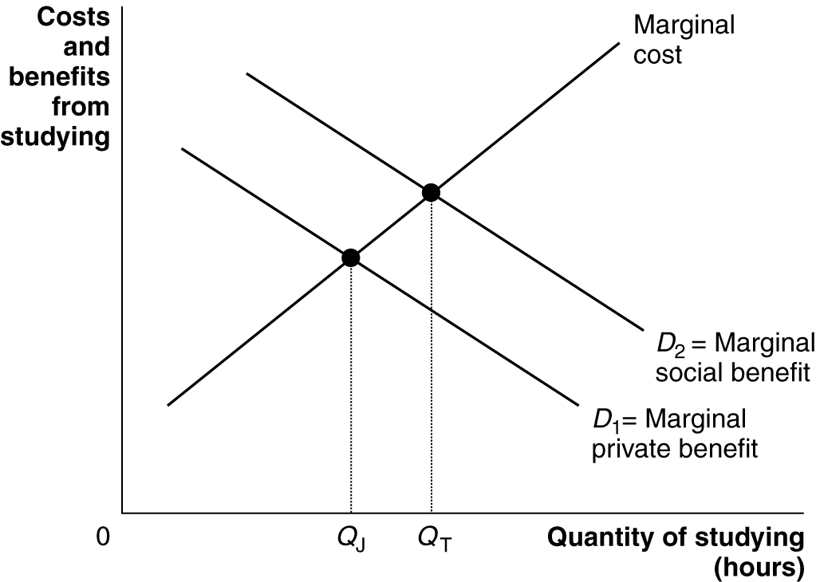

Tom’s demand for studying is D₂, the marginal social benefit curve, which adds together his marginal private benefit and the marginal external benefit to his future children. He studies Q_{T} hours, which is the efficient amount. Jacob studies only Q_{J}, which is inefficient because the marginal social benefits from studying more exceed the marginal costs.

24. Private goods include mail delivery (you’ll be excluded if you don’t use a stamp), education in a private school, hiking in a park surrounded by a fence, and an apple. A TV broadcast and hiking in a park without a fence are public goods. Education in a public school is a common resource good – at least for people within the school district who won’t be excluded. It is rival because as more students crowd into a classroom, the amount of attention the teacher gives to each student declines. In cases where it isn’t rival, it would be a public good for those who are eligible.

